Prompt

Breakdown
Breakdown here

Report

Report is subtab

Code and Plots
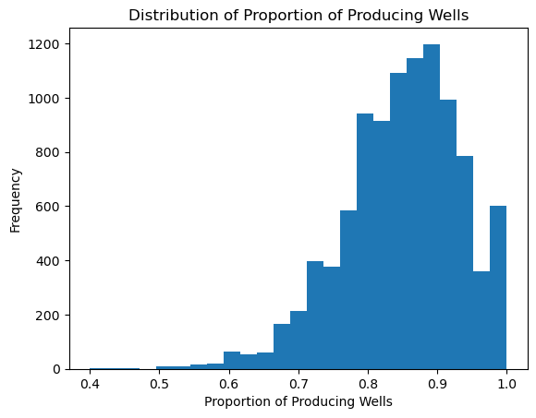

Report Here

Future Drilling Costs Simulation

Team 4
Lukman Awad, Irvin Carreon, Seamus Flaherty, April Groce, Grayson Nico

April 2, 2026

Table of Contents

Overview 1
Methodology 1
Data Used 1
Methods 1
Analysis 1
Simulating Well Production 1
Simulating Project NPV 2
Results & Recommendations 4
Results 4
Recommendations 6

Future Drilling Costs Simulation

Overview
Compagnie Pétrolière et Gazière, Inc. (hereafter referred to as “Company”) faces a big risk in drilling operations due to the possibility of drilling in dry holes, resulting in temporal and monetary losses. The Company has requested a simulation of project-level well outcomes along with statistics on the project’s financial success for Phase 2 of their exploration process.

To address these requests, our team simulated well outcomes and calculated statistics for the project’s Net Present Value (NPV), Value at Risk (VaR), and Conditional Value at Risk (CVaR). After considering oil price projections for the next 15 years along with the Company’s provided revenue and risk estimates, our simulations guaranteed non-zero profit. We therefore encourage the Company to pursue this investment.

Methodology
The following section describes the structure and preparation of the data for our simulation.

Data Used
Our team utilized a dataset containing estimated drilling costs for crude oil, natural gas, and dry wells from 1991-2007. The dataset included geometric annual changes on these costs. We also incorporated oil price projections from 2026 to 2050 for revenue calculations.

Methods
Using provided distributional and production assumptions for a single well, we ran a Monte Carlo simulation on the probability of the number of producing wells in the entire project. The number of wells in each project was modeled as a Uniform distribution between 10 and 30, and each well’s production outcome was simulated using a Binomial distribution with an 85% probability of producing and 15% probability of being a dry well.

We used this information, combined with our Phase 1 estimates of 2025 drilling costs, to perform a Monte Carlo simulation on the distribution of NPV for the entire project. Our analysis assumes that wells that produce will do so for 15 years and uses a 10% weighted average cost of capital (WACC) in the NPV calculation. We calculated expected risk and return from dry wells and producing wells.

In addition to the Monte Carlo simulation, we developed a base-case NPV model using mean or most likely values for all inputs. This deterministic model provides a benchmark estimate of project value and allows for comparison with the Monte Carlo simulation of NPV, which captures uncertainty and risk not captured by the base-case model.

Analysis
This section presents our simulation of project-level well production and NPV.

Simulating Well Production
Before simulating well production, the Company informed us that the probability of a producing well was 85%. They also specified that the number of planned wells in the project is expected to be uniformly distributed between 10 and 30. With this information, we ran a simulation of the number of wells in the project, including dry wells. Figure 1 visualizes the distribution of the proportion of producing wells.

Figure 1: Distribution of proportion of producing wells.

The high concentration of values near 0.85 along with the left skew in Figure 1 indicates that in general, we anticipate the proportion of producing wells to be between 70% and 95%. While there is still a moderate chance of the proportion falling below 70%, the chance of this proportion following below 50% is nearly zero. Therefore, the Company can expect around 85% of the project’s planned wells to produce.

Simulating Project NPV
We leveraged our analysis from Phase 1 to simulate the project’s NPV. During Phase 1, we concluded that drilling costs per well are projected to increase to an average value of approximately $4.4M in 2025, when assuming a Normal distribution for the simulation. We also found that the probability of costs falling below the initial estimate is approximately 7.85%. After reporting this information, the Company provided additional metrics related to anticipated project costs and revenue to simulate the project’s NPV. Table 1 summarises the expenses that occur at Year 0 before oil production begins.

Table 1: Year 0 Expenses.
Expense | Description | Cost | Relevant Distribution
Drilling Costs | Simulated drilling costs calculated during Phase 1. | $4.4M per well (expected) | Varies by year; see Phase 1 report for more details.
Drill Rights | The right to drill on land surrounding a project well. | $960 per acre (per well) | Total acres per well ~ $Normal(600, 50^{2})$
Seismic Data | Data purchased to choose the optimum well location. | $43k per section (per well) | Total sections per well ~ $Normal(3, 0.35^{2})$
Completion Cost | Cost of oil production at optimum sustainable rate (given that the well is not dry). | Varies by well | Cost per well ~ $Normal(\$390k, \$50k^{2})$
Overhead | Annual costs of project team salary and benefits, based on total time spent on well. | Varies by well | Cost per well:  - Most likely: $215k  - Minimum: $172k  - Maximum: $279.5k
Table 1 indicates that pre-production costs often vary by well, which emphasizes the importance of accurately estimating how many producing wells will be included in the project. Fortunately, these values are only accrued during Year 0, with the exception of annual overhead costs. Overall, pre-production costs amount to approximately $5.7M per producing well.

This project must generate enough overall revenue to cover these major expenses with an acceptable profit margin. To help simulate expected revenue, the Company provided information on production risk factors, which are summarized in Table 2.

Table 2: Production risk factors.
Factor | Description | Distribution/Equation
Initial Production Rate (IP) | Rate that oil is produced at Year 1, measured in barrels of oil per day (BOPD). | IP’s ~ $LogNormal(420, 120^{2})$  Underlying distribution ~ $Normal(6, 0.28^{2})$
Decline Rate (DR) | Decline in production rate as reservoir energy and volumes deplete over time, measured in BOPD. | DR ~ $Uniform(15, 32)$
Annual Production Rate (APR) | Overall production rate per year, measured in BOPD. | $Rate_{YearEnd}=(1-DR) ×Rate_{YearBegin}$
Annual Production Volume (APV) | Overall production volume per year, measured in BOPD. | $Oil_{VolumeYear}=365×\frac{Rate_{YearBegin}+Rate_{YearEnd}}{2}$
IP/DR Correlation | Correlation coefficient between IP and DR, imposed by the Company. | $Corr(IP,DR)=0.64$

From Table 2, our team noticed that the correlation coefficient between the IP and DR is moderately strong. This value therefore indicates that the decline rate increases as the initial production rate increases. Additionally, every well has its own rate of decline, so the distributions in Table 2 were used in our simulation to account for this uncertainty.

Next, the Company shared its estimates of certain revenue risk factors, as described in Table 3.

Table 3: Revenue risk factors.
Factor | Description | Distribution/Equation
Annual Oil Price | Projected oil prices per barrel for the next 15 years, provided by the U.S. Energy Information Administration. | Price ranges over time:  - Most likely: $85.26 to $97.68  - Minimum: $45.75 to $49.74  - Maximum: $166.26 to $185.28
Net Revenue Interest (NRI) | Percentage of oil revenue retained by the Company after royalties. Constant over lifetime per well. | NRI ~ $Normal(75\%, 2\%^{2})$
Annual Revenue | Pre-royalty revenue generated in a given year. | $Revenue_{Year}=OilPrice_{Year}×APV_{Year}$

Table 3 includes the royalties that must be paid out on each well, with each well potentially having different royalty values. This project should therefore include enough wells with adequate production volume to ensure that post-royalty revenue meets an acceptable threshold.

Finally, the Company included operating costs and taxes for West Texas, which are specified in Table 4.

Table 4: Operating expenses.
Factor | Description | Distribution/Equation
Production Costs | Cost of manpower and hardware involved in the production process, measured in dollar amount per barrel. | Cost per barrel ~ $Normal(\$2.25, \$0.30^{2})$
Severance Taxes | Constant state taxes levied on produced oil and gas, applied after the NRI. | $4.6\%$ of annual revenue.

Table 4 shows that production costs and severance taxes make up the Company’s operating expenses. These expenses are subtracted from the Company’s gross sales to obtain their net sales.

These four tables summarize the collective risks and revenue streams that impact the NPV of the entire project. With this information in mind, we simulated the distribution of NPV for the entire project.

Results & Recommendations
This section outlines the results of our analysis and gives recommendations for future decision-making.

Results
The outcome of our team’s base-case NPV was $331M, which provides the benchmark estimate of project value. This value aligns with the mean NPV from the Monte Carlo simulations, which was $332.6M. Both of these numbers indicate that the project will be profitable for the Company.

Figure 2 depicts the entire distribution of simulated NPV values, which incorporates our simulations of the risk and revenue stream factors. The navy line represents the CVaR; the red line represents the VaR.

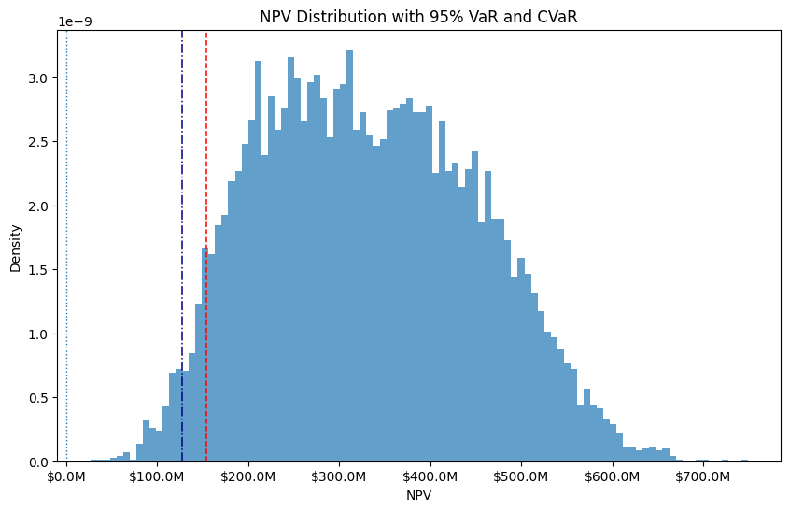
Figure 2: Simulated distribution of the entire project’s NPV.

The distribution in Figure 2 immediately indicates that the project is guaranteed to yield a positive NPV for the Company, with 0% of the area falling on or below the $0 threshold. The red VaR line indicates that in the worst 5% of project outcomes, project NPV is estimated to be $182.4M or lower. Similarly, the navy CVaR line indicates that within these worst 5% of outcomes, the expected project NPV is estimated to be $147.9M. For further comparisons across possible project outcomes, Table 5 provides risk and shortfall metrics at three different confidence levels. Note that the confidence levels correspond with a tail probability of $1-Confidence\%$.

Table 5: VaR and CVaR statistics at different confidence levels.
Confidence | VaR (5% Tail Threshold) | NPV* - VaR Loss | CVaR (Average 5% Tail NPV) | NPV* - CVaR Loss
90% | $182.4M | $150.3M | $147.9M | $184.8M
95% | $154.2M | $178.4M | $127.0M | $205.6M
99% | $109.8M | $222.8M | $90.0M | $242.6M
*NPV = $332.6M

Table 2 indicates that across all three confidence intervals, the CVaR estimate is at least $19M lower than the VaR threshold. This difference indicates a strong tail risk, since project NPV is expected to be at least $19M lower than the VaR threshold in the worst 5% of possible project outcomes. Conversely, when looking at the difference between expected NPV and VaR/CVaR, Table 2 indicates that the Company is expected to lose $178.4M or more in the worst 5% of outcomes. In these scenarios, the average loss is expected to be about $205.6M, which is $27.2M more than the worst 5% NPV threshold.

Fortunately, none of the scenarios are expected to result in a negative NPV. Even in the worst 1% of project outcomes, project NPV is projected to be $90M on average. While the Company has not specified a target NPV, our team strongly believes that this value indicates a relatively safe project investment.

Recommendations
Assuming that the historical data provided by the Company continues to apply to present scenarios (i.e., barring any major climate event or policy change), our model predicts a 100% probability of positive NPV. Therefore, our team recommends proceeding with this investment. The CVaR indicates that even in the worst 5% of scenarios, the average loss is only $205.6M lower than the mean, which still leaves the company with $127M in profit. Meanwhile, in the most likely scenarios, this project would offer the Company approximately $332.6M in profits.

Conclusion
Our team performed a simulation of well outcomes for the Company’s prospective drilling operation. We used historical data on estimated drilling costs, Company-provided estimates for risk and revenue, and additional outside assumptions (such as the WACC) to calculate project NPV in different scenarios. Our model found a 100% probability of profit on the investment, with the worst case scenario producing an average NPV of $90M. In the most likely scenarios, our team expects the Company to earn $332.6M on average; for this reason, we highly recommend that the Company move forward with this project.

HW Report Checklist

Homework Report Checklist - Team 4

As instructed by Hiya and Dr. Egan Warren, the team member(s) responsible for checking each item should enter their initials in the field next to each question. All items should be addressed before submitting the assignment with the initialed checklist attached.

Sections & Structure

Overview
IC | Is the overview concise?
IC | Does it provide context about the business problem? <Content>
IC | Does it briefly address your team’s work, quantifiable results, and recommendations? <Action>
IC | Does it offer audience-centered reasons for recommendations? <Context>

Body Sections
IC | Does the report body include information on methods, analysis, quantifiable results, and  recommendations?
IC | Is content grouped into appropriate sections (methodology, analysis, results, recommendations)?

Conclusion
IC | Does the report have a conclusion?
IC | Does the conclusion sum up the report and emphasize relevant takeaways?

Structure
IC | Does each major section have a heading?
IC | Are sections, subsections, and paragraphs organized logically for easy navigation?

Visuals

Introduction, Discussion, and Captions
SJF | Is each visual introduced in the text before it appears?
SJF | Is each visual close to where it is introduced?
SJF | Does each visual include a title with the following information: type (table or figure), number, and a  descriptive caption?
SJF | Is each visual discussed and interpreted in the text?
SJF | Are figures and tables numbered separately?
SJF | Are table captions above the table? Are figure captions below the figure?

Visual Design
LA | Do figures/tables use audience-friendly labels rather than variable names?
LA | Are the visuals easy to interpret?
LA | Are the visuals appropriately sized?
LA | Do tables appear on one page (not split between 2 pages)?
LA | Are legends and axis labels included for figures?
LA | Are numbers in tables right aligned?
LA | Are the visuals designed well (ex: re-created in Word or Excel, not blurry or stretched,…)?

Document Design

Title Page Design
IC | Does it include a descriptive title?
IC | Does it state the team name, team members’ names, and the submission date?

Table of Contents Design
LA | Does it list all the major sections of the report with corresponding page numbers?
LA | Do the page numbers and sections in the Table of Contents match the report?

Document Design for Entire Report
SJF | Is a standard typeface (Calibri, Arial, etc.) used?
SJF | Is the size of the body text between 10-12 pt.?
SJF | Are headings and subheadings used to organize information?
SJF | Are distinctive text styles (bold, italic, etc.) used to distinguish between heading levels?
IC | Are text styles for headings used consistently (ex: all level-one headings are bold)?
IC | Are all paragraphs an appropriate length (fewer than 12 lines)?
IC | Is white space used to indicate paragraph breaks?
IC | Are bullet lists used for a series of items and numbered lists to show a hierarchy?

Writing Style and Mechanics

Spelling and Capitalization
GN | Are spelling errors located and corrected?
GN | Is spelling consistent throughout (no switching between acceptable spellings)?
GN | Is capitalization used appropriately (proper nouns, etc.)?
GN | Is capitalization of words consistent throughout the report?

Grammar and Punctuation
GN | Are verb tenses used appropriately?
GN | Are marks of punctuation used appropriately?
GN | Is subject-verb agreement used in every sentence?
GN | Is the grammar checker updated and are underlined grammar issues addressed?

Writing Style
GN | Are all sentences in the report easy for your audience to understand quickly?
GN | Are most sentences written in active voice?
GN | Are idioms and vague words eliminated from the report?
GN | Are acronyms introduced before being used?
GN | Are well-written topic sentences included at the beginning of each paragraph?
GN | Are lists parallel?
GN | Is the appropriate point of view used when addressing your audience or describing team actions?

Scratchwork
GRAY’S NOTE: this tab contains my notes taken on everyone’s code; want to make sure I’m following what everyone is doing

APRIL’S WORKFLOW:
- Read in the oil projection dataset for annual oil prices (needed for annual revenue)
- Read in the drilling cost dataset
- Ran simulation (10000 runs) to identify number of producing and dry wells for project
  - Planned wells ~ Unif(10, 30)
  - Producing wells ~ Binomial(1, 0.85)
- Created histogram based on simulation to visualize distribution of producing well proportion


- Read in drilling cost data from 1996 to 2006; calculated average cost in 2006 for starting point
- Used HW1 to calculate the Year 0 costs
  - 2006-2012 ~ Normal(mean(‘Change’), std(‘Change’))
  - 2012-2015 ~ Uniform(-0.22, -0.07)
  - 2015-2024 ~ Uniform(0.02, 0.06)
  - 2025 ~ Uniform(0.02, 0.06)
- Obtained the following costs:
  - Lease cost: $576k
  - Seismic cost: $129k
  - Completion cost: $390k
  - Overhead cost: $215k
  - TOTAL YEAR 0: $5,749,238 ($5.75M)
- Calculated production risk per year with IP (420) and DR (0.235) as well as yearly production volume
- Calculated revenue risk per year with oil price (given, triangularly distributed) and net revenue interest (75%)
- Calculated operational expenses with total yearly operating costs (15 years) and total yearly taxes (applied after NRI)
- Calculated yearly cash flows based on annual revenue, operating costs, taxes, and overhead
- Calculated NPV with cash flow, initial costs, and the average of 20 weeks in project (assumed producing)
- Simulated the distribution of NPV for a single well
- Used the above distribution to simulate NPV for the entire project (1000 sims)
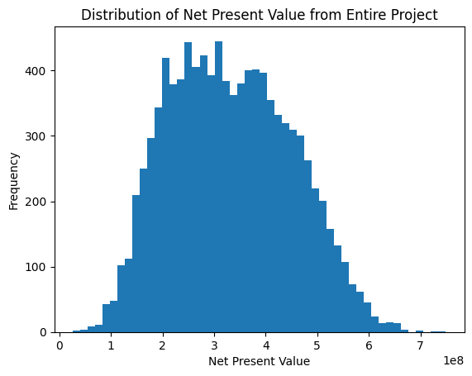
- Average NPV for entire project: $332M

SEAMUS’S WORKFLOW:
- Reworked HW1 - why?
- Simulated the following variables (SAME DISTRIBUTION AS APRIL)
  - Expected wells per project: 19.9
  - Expected producing wells: 17.0 → how many acres/sections?
  - Expected dry wells: 3.0
  - Expected proportion of producing wells: 85%
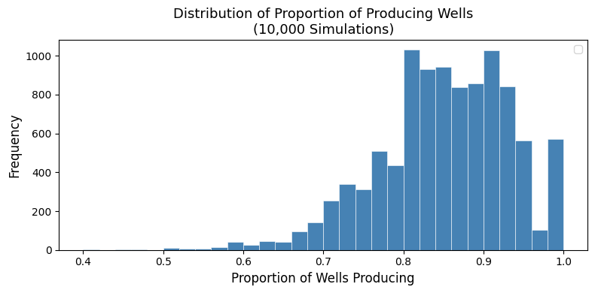

- Read in oil price distributions and identified expected price forecasts
  - Year 1 (2026): $98.82 (standard deviation = $25) → need annual production for annual revenue
  - Year 15 (2040): $104.91 (standard deviation = $26.50) → need annual production for annual revenue
- Simulated production metrics
  - Expected Initial Production (IP) rate: 419.3 barrels per day (standard deviation = 119.5 barrels per day)
  - Expected Decline rate (DR): 0.235 barrels per day (standard deviation = 0.0459 barrels per day)
  - Expected Production Rate: (1 - 0.235) * (419.3) = 320.7645
  - Expected Annual Production: 365 * (419.3 + 320.7645) / 2 = 135,061.771 barrels per year
    - Simulated Year 1 Production per Well: 134,420 barrels per well
  - Correlation between IP and DR: 0.611 (target = 0.64)
- Simulated revenue production and calculated operating costs; used metrics to calculate NPV
  - Expected NPV: $327.54M (median = $315.90M)
    - Standard deviation: $123.93M
    - Minimum: $34.33M → company should invest in this project
    - Maximum: $848.10M
- Calculated expected shortfall
  - VaR: $148.23M
  - CVaR: $122.06M
  - Probability of Loss: 0%

